# Linear Algebra – Week 4-5

Matrices as objects that map one vector into another

Matrix multiplication using Einstein Summation method.

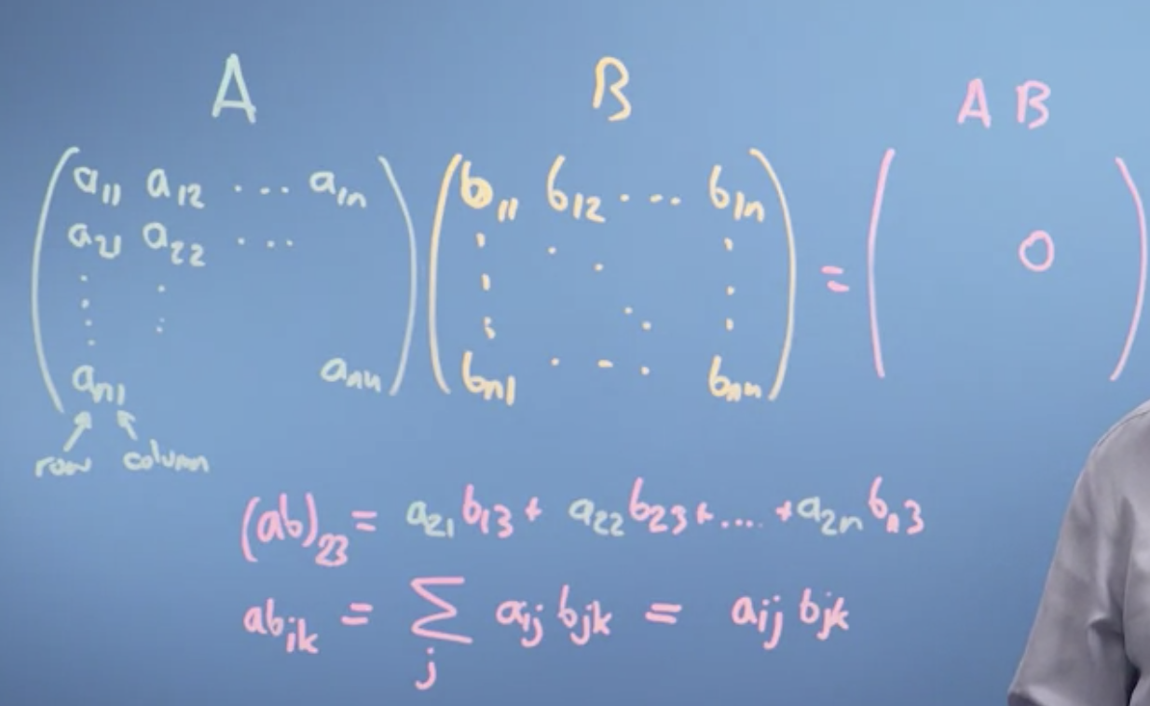



Some resemblance between unit vector and the dot product.

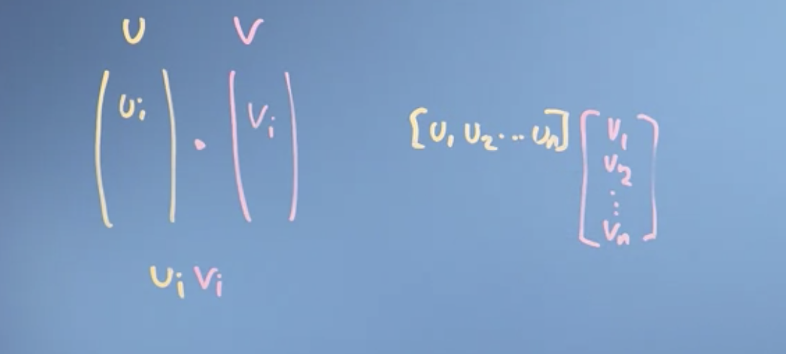

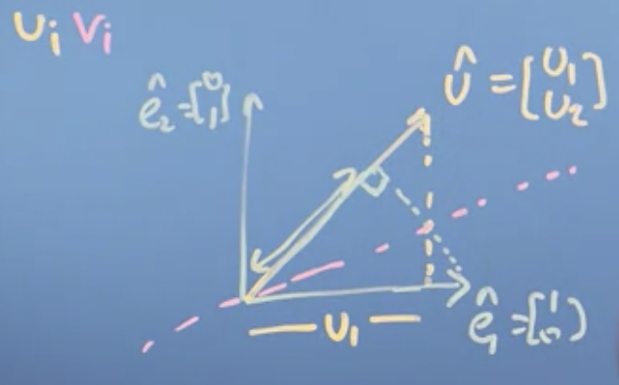

And that's why we talk about a matrix multiplication with a vector as being the projection of that vector onto the vectors composing the matrix, the columns of the matrix.

Change of basis vectors:

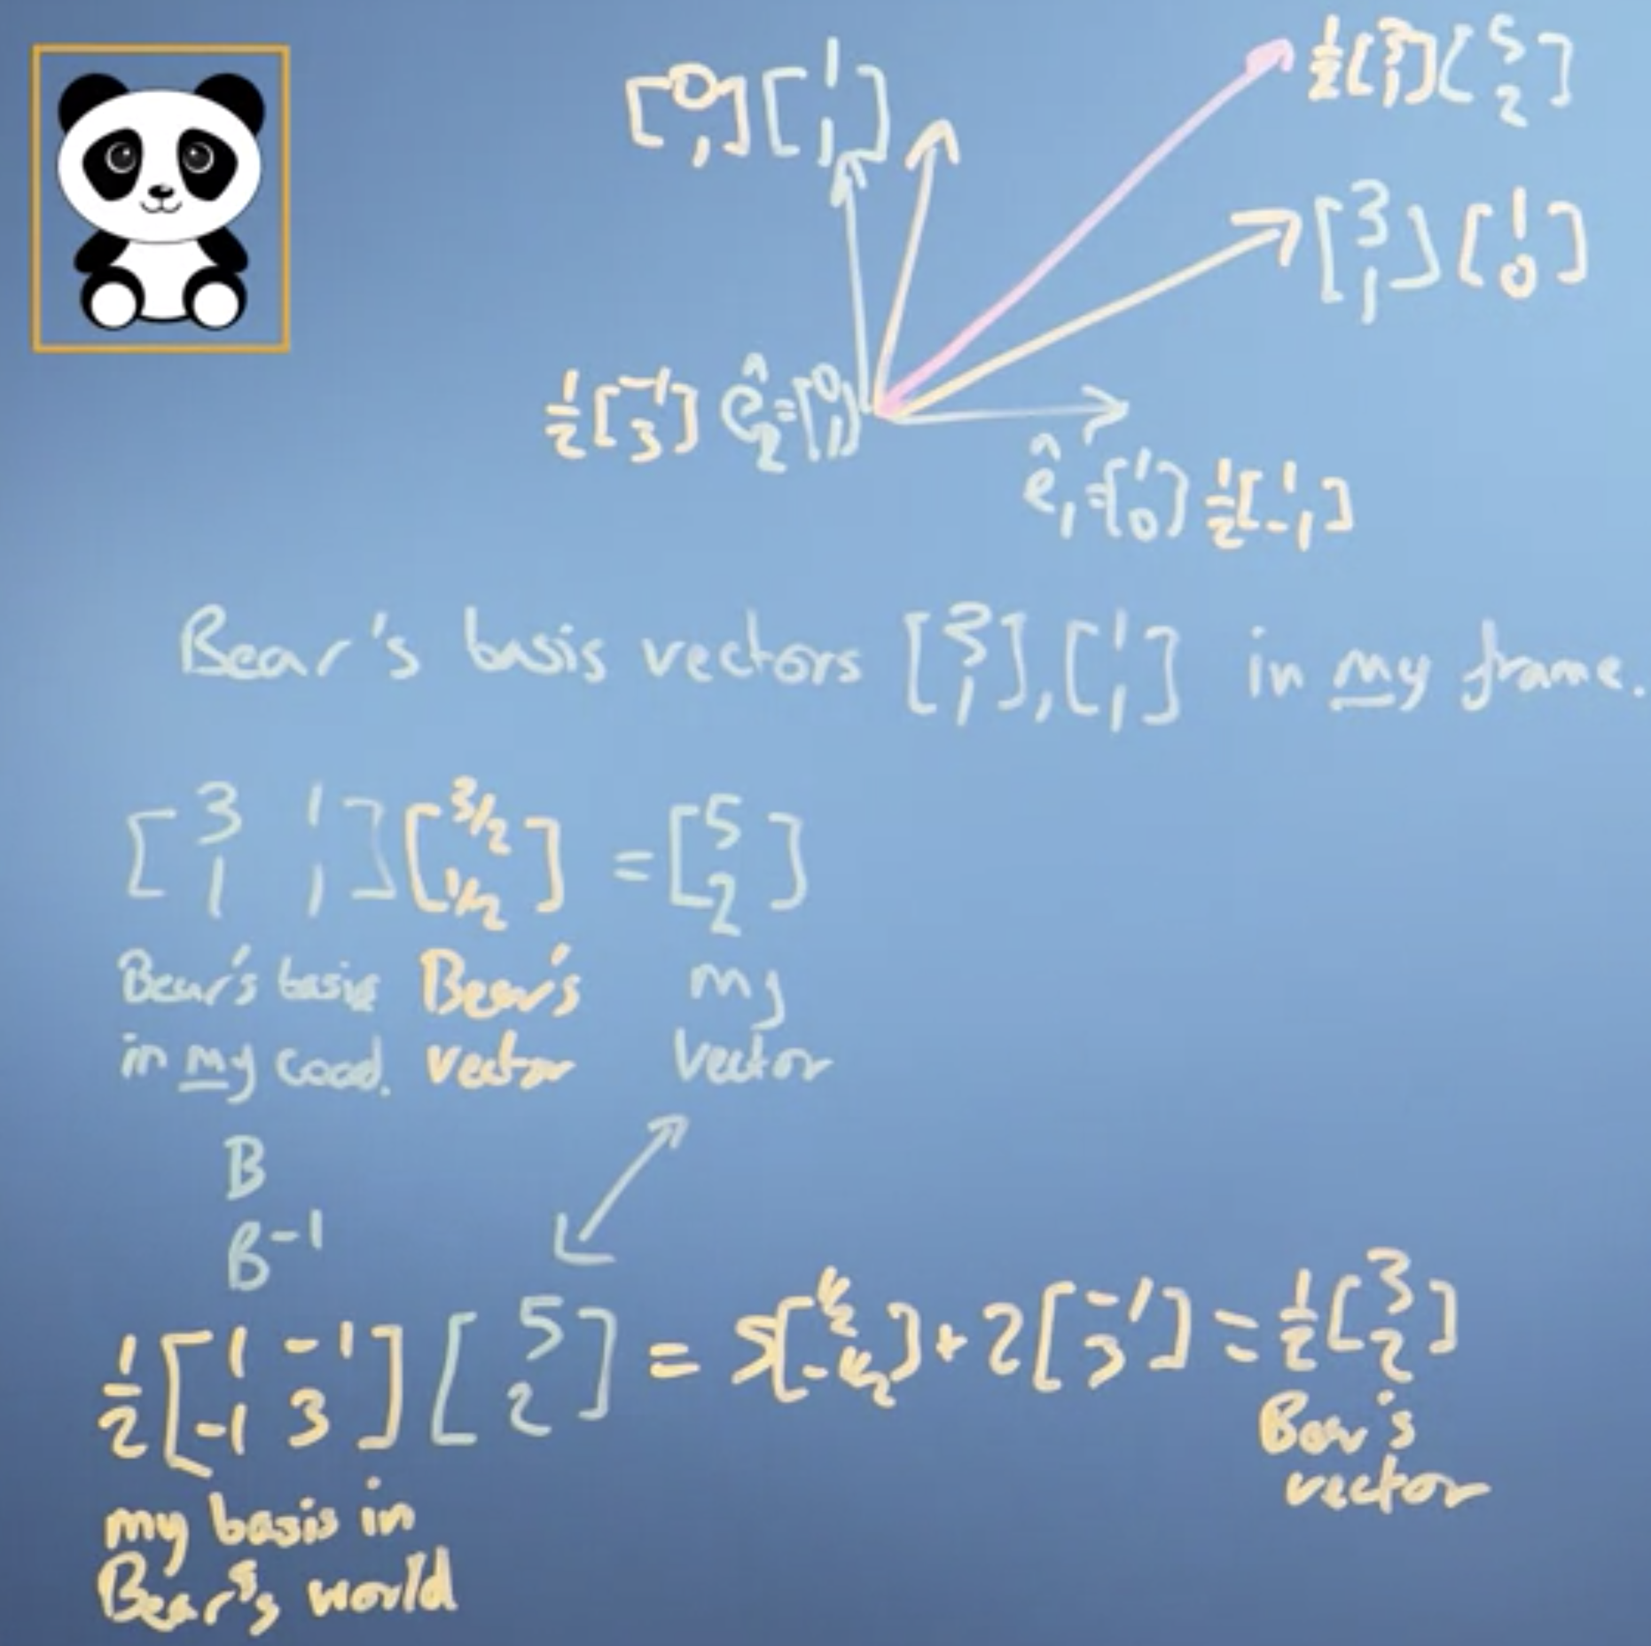

So that's how you do the reverse process. If you want to take Bear's vector into my world, you need Bear's basis in my coordinate frame, and if you want to do the reverse process, you want my basis in Bear's co-ordinate frame.

Now, this was all prep really for the fun part, which is, we said before in the vectors module that we could do this just by using projections, if the new basis vectors were orthogonal, which these are. So let's see how this works with projections.

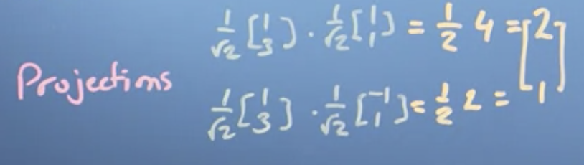

So I've used projections here to translate my vector to Bear's vector just using the dot product. Now remember, with the vector product, what I'd have to do is I'd have to remember to normalize when I did the multiplication by Bear's vectors, I'd have to normalize by their lengths. But in this case, their lengths are all one. So it's actually really easy. So we don't have to do the complicated matrix maths, we can just use the dot product if Bear's vectors are orthogonal. Now, there is one last thing.

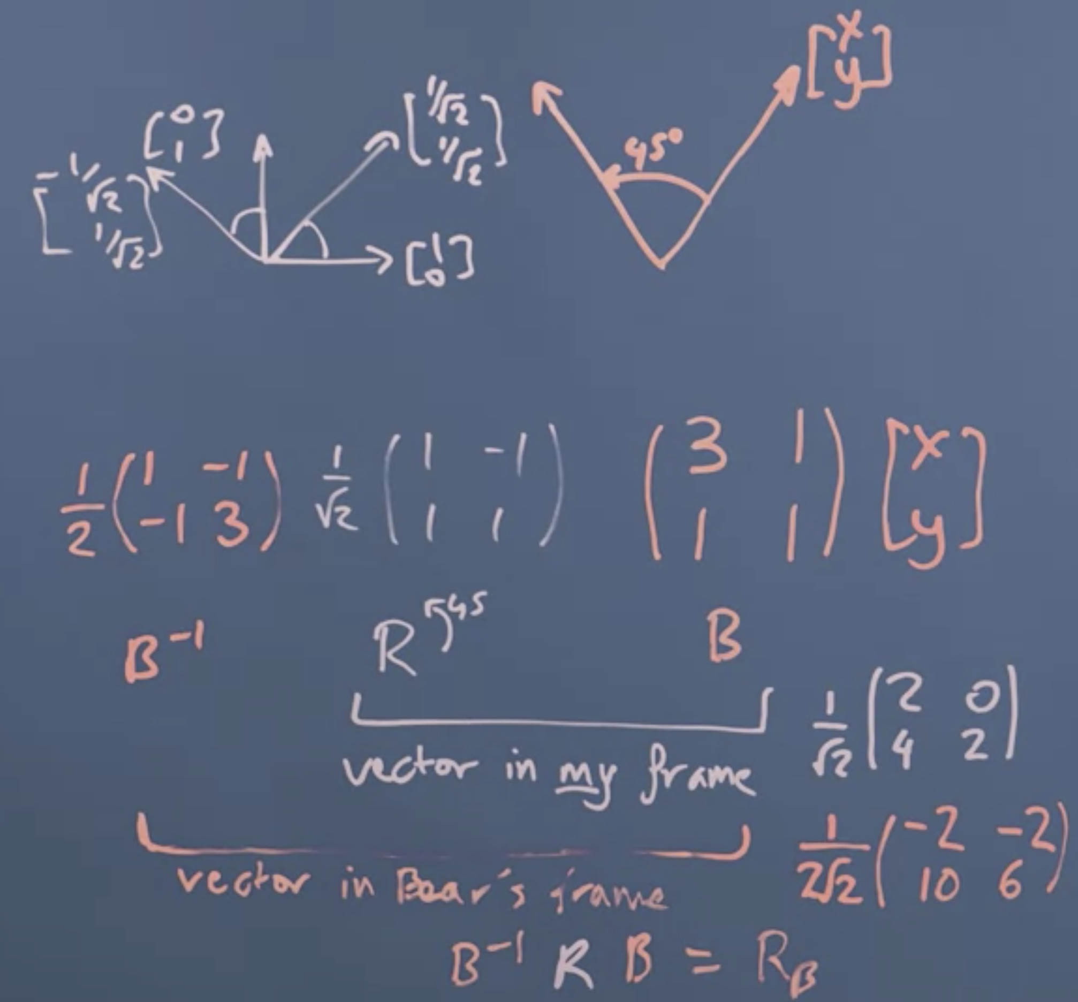

Since, we don’t know the rotation in the new basis vector space. We convert the vector to our basis vector and rotate it and then convert back to the new basis vector representation. We thought about the coordinate systems and how to do transformations in non-orthogonal coordinate systems. It's been quite hard work, but this really sets us up for example in principal component analysis, to operate in different basis systems.

Orthonormal Basis Vectors:

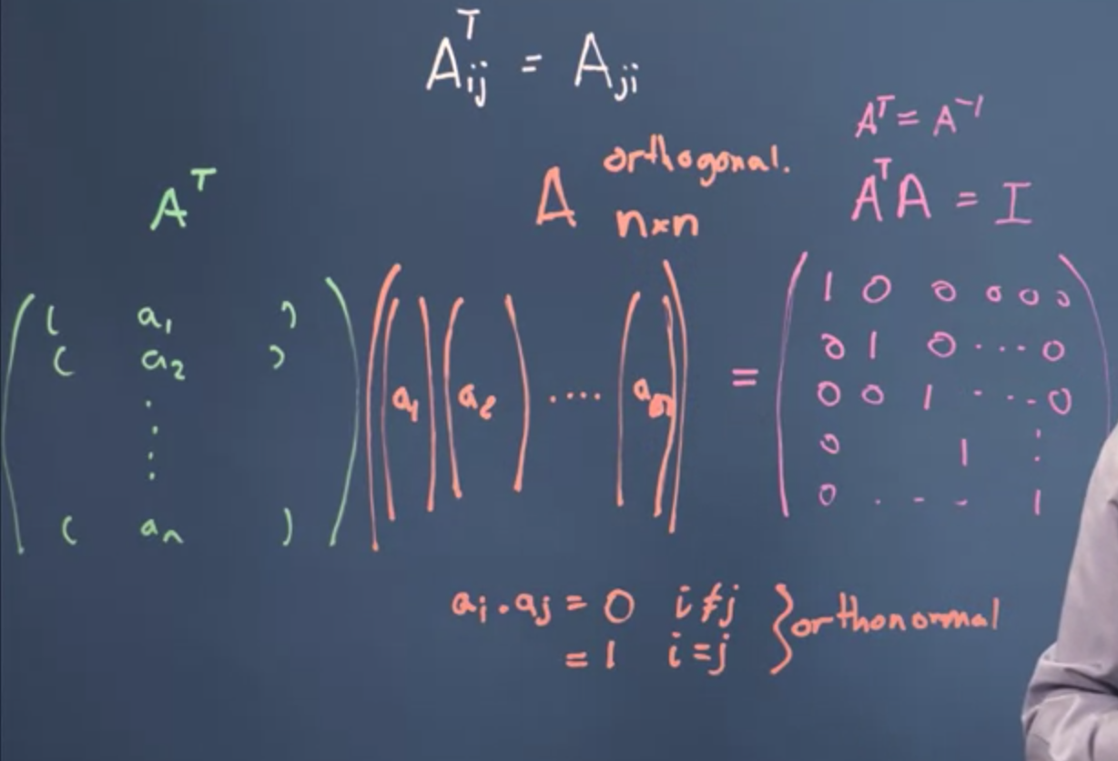

So what I found is that A_t times A gives me the identity matrix, and what that means is, is that A_T is a valid inverse of A. Which is really kind of neat. A set of unit length basis vectors that are all perpendicular to each other are called an **orthonormal basis set,** and the **matrix composed of them is called an orthogonal matrix**

Now in data science what we're really saying here is that wherever possible, we want to use an orthonormal basis vector set when we transform our data. That is, we want our transformation matrix to be an orthogonal matrix. That means the inverse is easy to compute. It means the transmission is reversible because it doesn't collapse space. It means that the projection is just the dot product. Lots of things are nice and pleasant, and easy. If I arrange the basis vectors in right order, then the determinant is one, and that's an easy way to check and if they aren't just exchange a pair of them and actually then they will be determinant one rather than the minus one. So what we've done in this video is look at the transpose and that's led us to find out about the most convenient basis factor set of all which is the orthonormal basis factor set which together make the orthogonal matrix whose inverse is its transpose.

**The Gram-Schmidt Process:**

How to construct an orthonormal basis vector set?

We've said several times now that life is much easier if we can construct an orthonormal basis vector set, but we haven't talked about how to do it. So in this video we'll do that starting from the assumption that we already have some linearly independent vectors that span the space we're interested in.

If you want to check linear independence you can write down their columns in a matrix and check the determinant isn't zero. If they were linearly dependent, that would give you a zero determinant. But they aren't orthogonal to each other or of unit length.

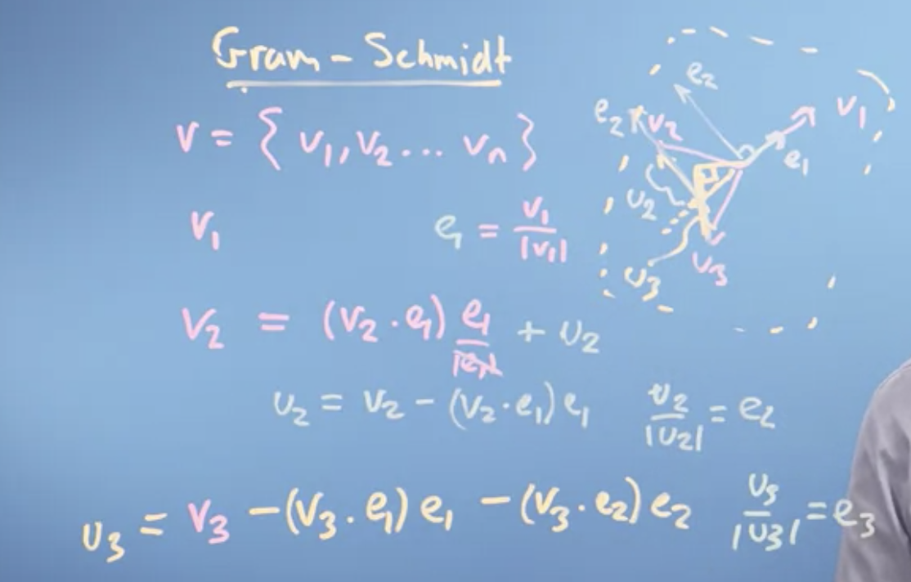

The Gram-Schmidt process is a method for constructing an orthonormal basis of a space that a set of given vectors span. It can also be used to determine the dimension of that space, which may be different than the dimension of the vectors themselves or the number of vectors provided to span the space.

So we're just going to normalize her and we're going to say that my eventual first basis vector e, is going to be equal to v1, just normalized to be of unit length. Just divided by that, its length. So, e is just going to be some normalized version of v1. And I can now think of v2 as being composed of two things. One is a component, let's do this in orange, a component that's in the direction of e1 like that, plus a component that's perpendicular to e1. But the component that's in the direction of e1, I can find by taking the vector projection v2 onto e1. So I can say v2 is equal to the vector projection of v2 onto e1 dotted together. And if I want to get that actually as a vector, I'll have to take e1, which is of unit length so I'd have to divide by the length of e1 but the length of e1 is one. So, forget it. And if I take that off of v2, then I'll have this guy, and let's call him u2. So I can then say that u2, so plus u2, so I can then rearrange this and say that u2 is then equal to v2 minus this projection v2.e1 times e1. And if I normalize u2, if I take u2 divided by its length, then I'll have a unit vector which is going to be normal to v1. So if I take a normalized version of that, let's say it's that, that will be e2. And that will be at 90 degrees to e1. So it'll actually be there, e2, once I've moved it over. And that will be another unit length vector normal to e1. So that's the first part of taking an orthonormal basis. Now my third vector v3 isn't a linear combination of v1 and v2, so v3 isn't in the plane defined by v1 and v2. So it's not in the plane of e1 and e2 either. So I can project v3 down, let's say something like that, onto the plane of e2 and e1, and that projection will be some vector in the plane composed of e2s and e1s. So I can then write down that v3 minus v3 dotted with e1, e1's. That's going to be the component v3 that's made up of e1's, minus v3 dotted with e2, e2's. That's the component of v3 that's made up of e2's. And then all that's going to be left is going to be this perpendicular guy there, so that's going to be a perpendicular vector which we'll call u3, which is perpendicular to the plane.

**Eigen – things:**

1. Geometric Understanding:

The word, 'eigen' is perhaps most usefully translated from the German as meaning characteristic. So when we talk about an eigenproblem, we're talking about finding the characteristic properties of something. But characteristic of what? This module, like the previous weeks, will try and explain this concept of eigen-ness primarily through a geometric interpretation, which allows us to discuss images rather than immediately getting tangled up in the maths.

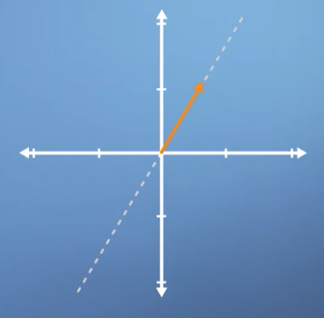

So, as you've seen from previous weeks, it's possible to express the concept of linear transformations using matrices. These operations can include scalings, rotations, and shears. Often, when applying these transformations, we are thinking about what they might do to a specific vector.

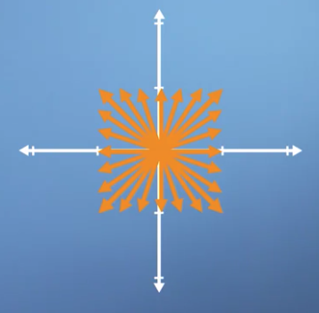  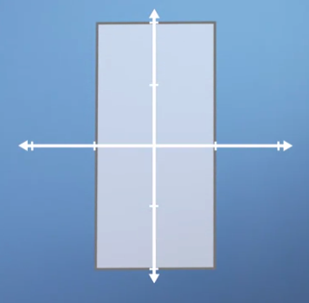 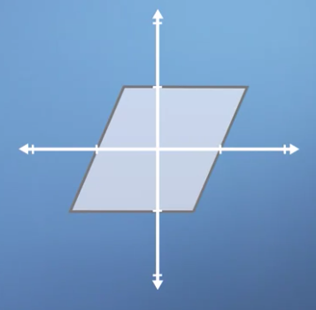

However, it can also be useful to think about what it might look like when they are applied to every vector in this space. This can be most easily visualized by drawing a square centered at the origin, and then seeing how your shape is distorted when you apply the transformation. So if we apply a scaling of two in the vertical direction, the square would now become a rectangle. Whereas, if we applied a horizontal shear to this space, it might look something like this. Now, here's the key concept, we are using our little square to help us visualize what is happening to many vectors. But notice that some vectors end up lying on the same line that they started on whereas, others do not.

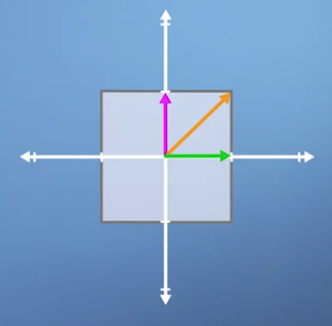 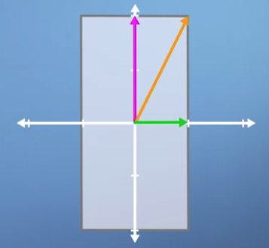

To highlight this, I'm going to draw three specific vectors onto our initial square. Now, let's consider our vertical scaling again, and think about what will happen to these three vectors. As you can see, the horizontal green vector is unchanged pointing in the same direction and having the same length. The vertical pink vector is also still pointing in the same direction as before but its length is doubled. Lastly, the diagonal orange vector used to be exactly 45 degrees to the axis, it's angle has now increased as has its length. I hope you can see that actually besides the horizontal and vertical vectors, any other vectors' direction would have been changed by this vertical scaling. **So in some sense, the horizontal and vertical vectors are special, they are characteristic of this particular transform, which is why we refer to them as eigenvectors**. Furthermore, because the horizontal vectors' length was unchanged, we say that it has a corresponding **eigenvalue of one** whereas, the vertical eigenvector doubled in length, so we say it has an eigenvalue of two.

**So, from a conceptual perspective, that's about it, for 2D eigen-problems, we simply take a transform and we look for the vectors who are still laying on the same span as before, and then we measure how much their length has changed. This is basically what eigenvectors and their corresponding eigenvalues are.**

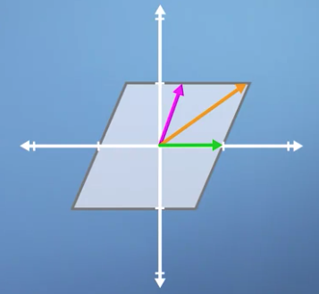 This has only one eigen vector which is the green horizontal line.

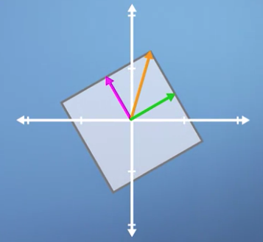 No Eigen Vectors at all. As all of the vectors have been rotated of their span.

For uniform scaling, any vector would be an Eigen vector.

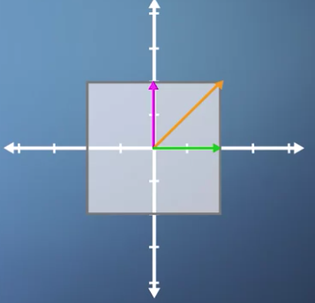

In this second example, we're going to look at rotation. In the previous video, we applied a small rotation, and we found that it had no eigenvectors. However, there is one case of non-zero pure rotation which does have at least some eigenvectors, and that is 180 degrees.

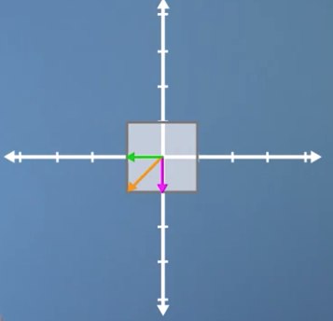 the three eigenvectors are still laying on the same spans as before, but just pointing in the opposite direction. This means that once again, all vectors for this transform are eigenvectors, and they all have eigenvalues of minus one, which means that although the eigenvectors haven't changed length, they are all now pointing in the opposite direction.

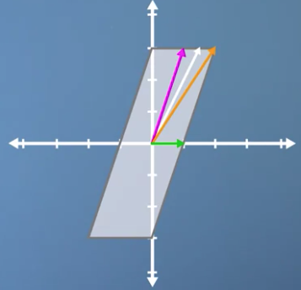 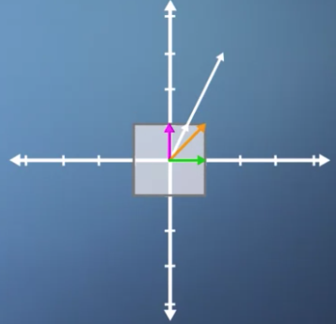 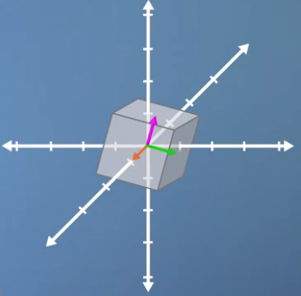

This problem is even tougher in three or more dimensions, and many of the uses of eigen theory in machine learning frame the system as being composed of hundreds of dimensions or more.

This means that the orange vector is an eigenvector, but it also tells us, as a physical interpretation, that if we find the eigenvector of a 3D rotation, it means we've also found the axis of rotation.

1. Algebraic Understanding:
   1. 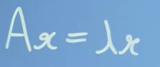

If we call our eigenvector x, then we can say the following expression. Ax = lambda x. Where, on the left-hand side, we're applying the transformation matrix A to a vector x. And on the right-hand side, we are simply stretching a factor x by some scalar factor lambda. So, lambda is just some number. We're trying to find values of x that make the two sides equal. Another way of saying this is that for our eigenvectors, having A apply to them just scales their length or does nothing at all, which is the same as scaling the length by a factor of 1.

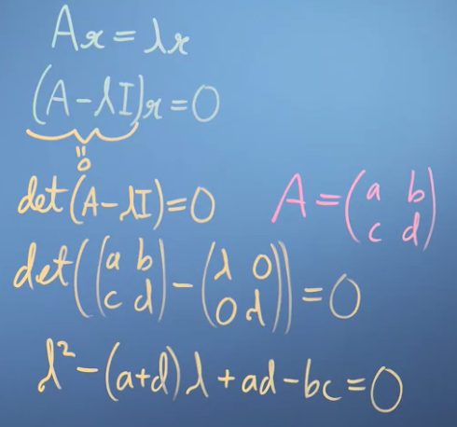

Subtracting scalars from matrices is not defined, so the I just tidies up the mathematics, without changing the meaning. So we're actually not interested in the case where the vector x is 0. That's when it has no length or direction and is what we call a trivial solution. Instead, we must find when the term in the brackets is 0. We can test if a matrix operation will result in a 0 output by calculating its determinant. So, det (A - lambda I) = 0. Calculating the determinants manually is a lot of work for high dimensional matrices. So let's just try applying this to an arbitrary two by two transformation.

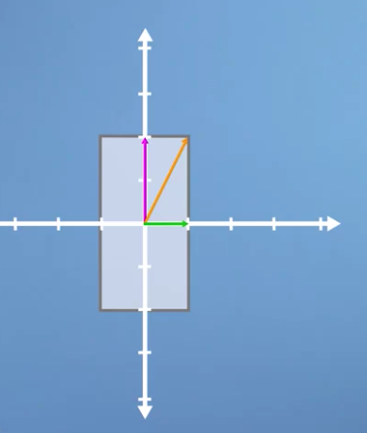

Vertical Scaling, with the factor of 2.

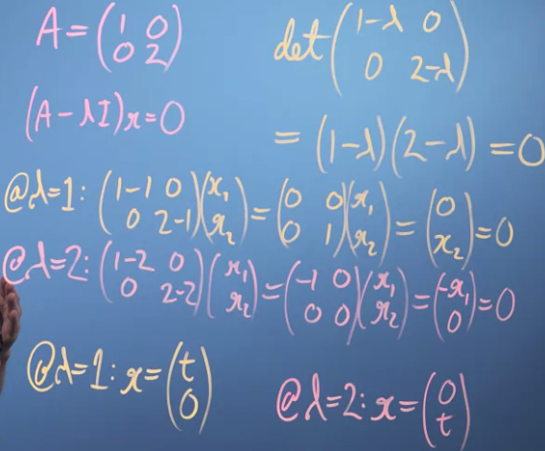

We can say that our eigenvector must equal 0,t. Because as long as it doesn't move at all in the horizontal direction, any vector that's purely vertical would therefore also be an eigenvector of this system, as they all would lie along the same span. So now we have two eigenvalues, and their two corresponding eigenvectors.

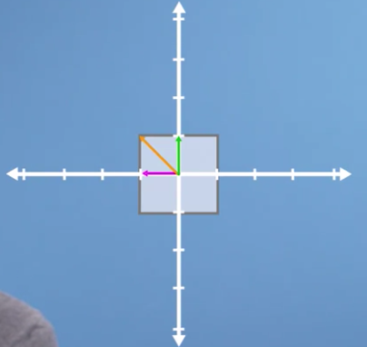

No Eigen Vectors here in a 90-degree rotation.

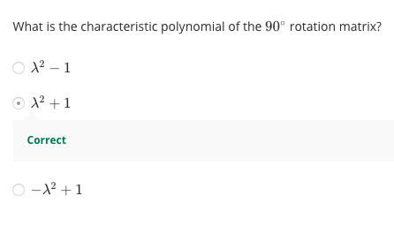

Which doesn't have any real numbered solutions at all. Hence, no real eigenvectors.

**Changing to the eigen basis.**

So now that we know what eigenvectors are and how to calculate them, we can combine this idea with a concept of changing basis which was covered earlier in the course. What emerges from this synthesis is a particularly powerful tool for performing efficient matrix operations called diagonalisation.

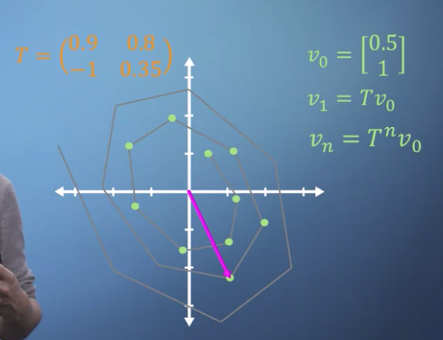

Sometimes, we need to apply the same matrix multiplication many times. For example, imagine a transformation matrix T

Start transcript at 28 seconds0:28

represents the change in location of a particle after a single time step. So we can write that our initial position, described by vector v0, multiplied by the transformation T gives us our new location, v1. To work out where our particle will be after two time steps, we can find v2 by simply multiplying v1 by T, which is of course the same thing as multiplying v0 by T two times. So v2 equals T squared times v0. Now imagine that we expect the same linear transformation to occur every time step for n time steps. Well we can write vn is T to the power of n, times v0. You've already seen how much work it takes to apply a single 3D matrix multiplication. So if we were to imagine that T tells us what happens in one second, but we'd like to know where our particle is in two weeks from now, then n is going to be around 1.2 million, i.e., we'd need to multiply T by itself more than a million times, which may take quite a while.

If all the terms in the matrix are zero except for those along the leading diagonal, we refer to it as a diagonal matrix. And when raising matrices to powers, diagonal matrices make things a lot easier.

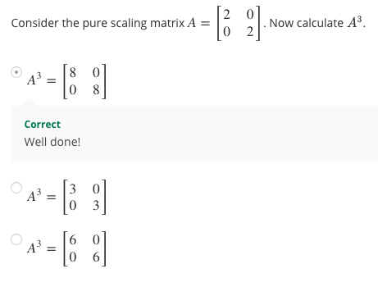

It's simple enough, but what if T is not a diagonal matrix? Well, as you may have guessed, the answer comes from eigen-analysis. Essentially, what we're going to do is simply change to a basis where our transformation T becomes diagonal, which is what we call an eigen-basis. We can then easily apply our power of n to the diagonalized form, and finally transform the resulting matrix back again, giving us T to the power of n, but avoiding much of the work. As we saw in the section on changing basis, each column of our transform matrix simply represents the new location of the transformed unit vectors. So, to build our eigen-basis conversion matrix, we just plug in each of our eigenvectors as columns.

Important: Note:

C equals eigenvector 1, eigenvector 2, and eigenvector 3 in this case as we are using a three-dimensional example. However, don't forget that some of these maybe complex, so not easy to spot using the purely geometrical approach but they are appear in the maths just like the others. Applying this transform, we find ourselves in a world where multiplying by T is effectively just a pure scaling, which is another way of saying that it can now be represented by a diagonal matrix. Crucially, this diagonal matrix, D, contains the corresponding eigenvalues of the matrix T.

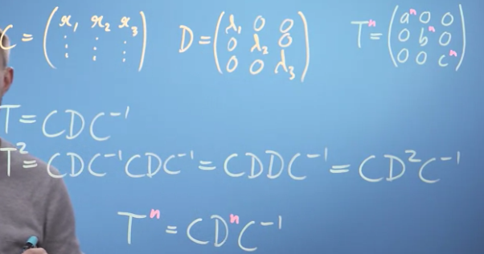

Bringing together everything we've just said, it should now be clear that applying the transformation T is just the same as converting to our eigenbasis, applying the diagonalized matrix, and then converting back again. So T = CDC inverse.

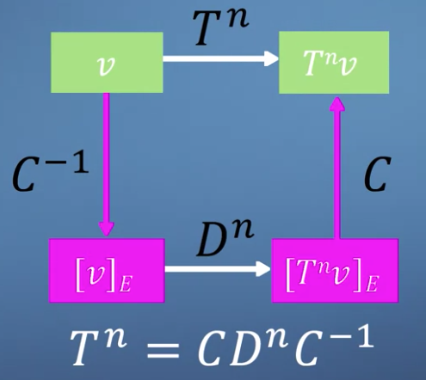

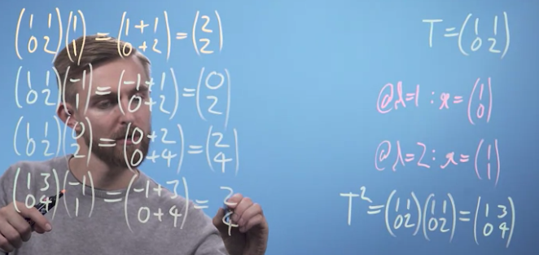

Using Eigen Vectors finding the results:

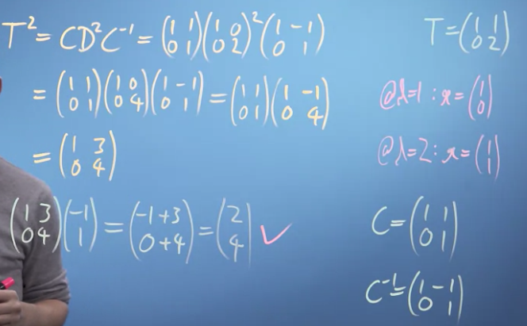

**Page Rank Algorithm:**

What we're trying to represent here with our matrix L is the probability of ending up on each of the pages.

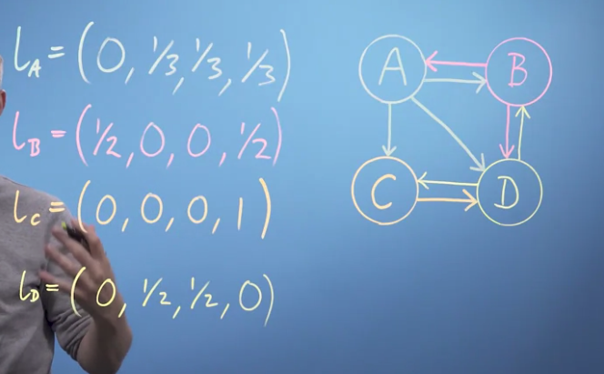

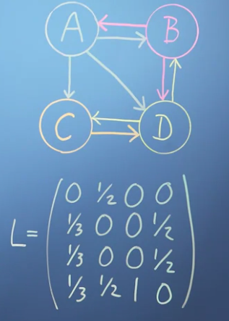

As you can see, this problem is self-referential, as the ranks on all the pages depend on all the others. Although we built our matrix from columns of outward links, we can see that the rows describe inward links normalized with respect to their page of origin.

Use the vector r to store the rank of all webpages. To calculate the rank of page A, you need to know three things about all other pages on the Internet. What's your rank? Do you link to page A? And how many outgoing links do you have in total?

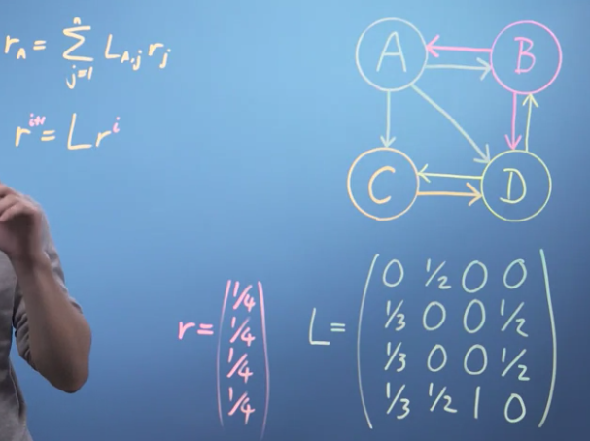

As it turns out, although there are many approaches for efficiently calculating eigenvectors that have been developed over the years, repeatedly multiplying a randomly selected initial guest vector by a matrix, which is called the power method, is still very effective for the page rank problem for two reasons. Firstly, although the power method will clearly only give you one eigenvector, when we know that there will be n for an n webpage system, it turns out that because of the way we've structured our link matrix, the vector it gives you will always be the one that you're looking for, with an eigenvalue of 1. Secondly, although this is not true for the full webpage mini Internet, when looking at the real Internet you can imagine that almost every entry in the link matrix will be zero, i.e,, most pages don't connect to most other pages. This is referred to as a sparse matrix. And algorithms exist such that multiplications can be performed very efficiently.

Damping factor D.

This adds an additional term to our iterative formula. So r i + 1 is now going to equal d, times Lri + 1- d over n. d is something between 0 and 1. And you can think of it as 1 minus the probability with which procrastinating Pat suddenly, randomly types in a web address, rather than clicking on a link on his current page.

